ONLINE NEWSPAPER

MD ATAULLAH KHAN RIFAT

ONLINE NEWSPAPER

MD ATAULLAH KHAN RIFAT

Supervised By

**Tangila Islam Tanni**

Lecturer

Department of Computer Science & Engineering

Faculty of Engineering

UNIVERSITY OF LIBERAL ARTS BANGLADESH

Dhaka, Bangladesh

MAY 2019

DECLARATION

I declare that this report entitled “Online Newspaper” is the result of my own research except as cited in the references. The report has not been accepted for any degree and is not concurrently submitted in candidature of any other degree.

Signature :

**Name :** MD ATAULLAH KHAN RIFAT

**ID :** 143014027

**Date :** MAY 11, 2019

**CERTIFICATE OF APPROVAL**

The project report entitled “*Online Newspaper*” is submitted to the Department of Computer Science and Engineering at University of Liberal Arts Bangladesh (ULAB) in partial fulfillment of the requirements for the degree of Bachelor of Science**.**

Dated: May 2019

**Department Head’s Name**

Designation & Head of Department

Computer Science and Engineering

University of Liberal Arts Bangladesh

**Supervisor’s Name**

Designation

Computer Science and Engineering

University of Liberal Arts Bangladesh

**DEDICATION**

To my lovely parents, who gave me endless love, trust, constant encouragement over the years, and for their prayers.

To my mentors and peers for their patience, support, love, and for enduring the ups and downs during the completion of this thesis.

This report/thesis is dedicated to them.

**ACKNOWLEDGEMENT**

First, I would like to convey my gratitude to almighty GOD for giving me the strength to perform my responsibility as an intern and complete the report within due time.

My special thanks go to supervisor Tangila Islam Tanni Lecturer, Department of Computer Science and Engineering, University of Liberal Arts Bangladesh (ULAB) for his cordial guidance, encouragement, and active help to prepare my internship report. He allocated valuable time throughout the Internship period to guide me for successfully completion of the internship and preparing this report.

Special thanks to my project supervisor Mr. Murad all her patience, guidance and support during the execution of this project. I wish to express my deepest appreciation to all those who helped me, in one way or another, to complete this project. First and foremost, I thank Almighty who provided me with strength, direction and purpose throughout the project.

Last but not the least; I would like to convey my gratitude to my colleagues, friends and teachers who gave me good advice, suggestions, inspiration and lots of support.

**ABSTRACT**

This report focuses on whose are read newspaper. Reader can easily read any type of news without seen advertisement.

I make a newspaper for everyone who try to know all update news in the word. If reader are followed our web online newspaper I make sure he or she knows all update news in the word and most importantly this newspaper is very eye catching for reader and no pop up any advertisement in this online newspaper.

|  |
| --- |
| **TABLE OF CONTENTS**  CHAPTER TITLE PAGE |

**DECLARATION**

**CERTIFICATE OF APPROVAL i**

**DEDICATION ii**

**ACKNOWLEDGEMENT iii**

**ABSTRACT iv**

**TABLE OF CONTENTS v-vi**

**CHAPTER 1** 1

**INTRODUCTION** 1

**Project Background** 2

**1.2 Statement of Problem** 3

**1.3 Objectives** 3

**Arrangement of the Report** 4

**CHAPTER 2** 5

**COMPANY PROFILE** 5

**2.1 Services** 5

**2.2 Roles and Responsibilities** 6

**CHAPTER 3** 7

**Technologies** 7

**3.1 Hardware** 7

**3.2 Software** 7

**3.2.1 Languages: PHP (OOP)** 7

**3.2.1 Design: Bootstrap** 8

**3.3 Work Breakdown Shape of Online Newspaper** 9

**Chapter 4** 10

**PROPOSED PROJECT** 10

**4.1 Project Background** 10

**4.1.1 Flow Chart for Online Newspaper** 10

**Investigate and Fix Problems** 10

**4.1.2 Class Diagram for Online Newspaper** 13

**Motivation behind Class Diagrams** 13

**Class Relationships** 13

**4.1.3 ER Diagram for Online Newspaper** 15

**Database plan:** 15

**Database investigating:** 15

**Business data frameworks:** 15

**Business process re-designing (BPR):** 15

**Training:** 15

**Research:** 15

**4.2 Admin Panel** 17

**4.2.1 Login page** 18

**4.2.2 Admin Home Page** 19

**4.2.3 Category of News** 20

**4.2.4 News** 21

**4.2.5 Featured photo** 23

**4.2.6 Admin adding** 24

**4.2.7 Breaking News** 25

**4.2.8 Logout** 26

**4.3 Newspaper page (Reader can see)** 27

**4.3.1 News Category** 32

**Chapter 5** 37

**Internship Activity** 37

**My Portfolio** 37

**5.1 Portfolio Home** 37

**5.2 Portfolio Resume** 39

**5.3 Portfolio Work** 40

**5.4 Portfolio Contact** 41

**Chapter 6** 42

**Conclusion** 42

**Reference** 44

# **CHAPTER 1**

## **INTRODUCTION**

Entry level position gives an astonishing open door for new alumni to increase some significant hands-on involvement, which can set them up for the extreme corporate life. As my profession objective is to fill in as a product designer in a presumed organization, I chose to join an organization as an understudy for some down to earth involvement. Luckily, I found an entry level position opportunity at KiloBit Ltd and my fantasy of turning into an expert programming designer ventured out.

In this report, I have depicted my three months' entry level position that I have done as a piece of the four year certification in Computer Science and Engineering. I was allotted to the Web Development group of my past involvement in this field. I had finished a few Web Development project extends in my University life, yet this was my first time working with a group of expert engineers. In these three months, I unquestionably took in a great deal about expert life and Web improvement, which will without a doubt help me to assemble my vocation. In particular, I have found out about filling in as a group to create useful applications in coordinated system to guarantee consumer loyalty and convey fast models.

This report contains subtleties of the undertaking that I have taken a shot at in these three months to finish my temporary position. I filled in as a full time understudy at KiloBit and my undertakings included something other than creating Web application. I am glad to pick up encounters, for example, going to meeting with undertaking chief for getting prerequisites and understanding task scopes, going to office gatherings and planning archives for other running activities at the organization.

### **Project Background**

My exercises spun around creating Web application. I was appointed to build up an Online Newspaper in web stage. Primary goal of this task is to make a web application with individuals can peruse and see update Bangladesh, which is helps any individuals. I chose to make a web application dependent on Online Newspaper for KiloBit, which will be proficient, efficient, solid, productive, secure and viable.

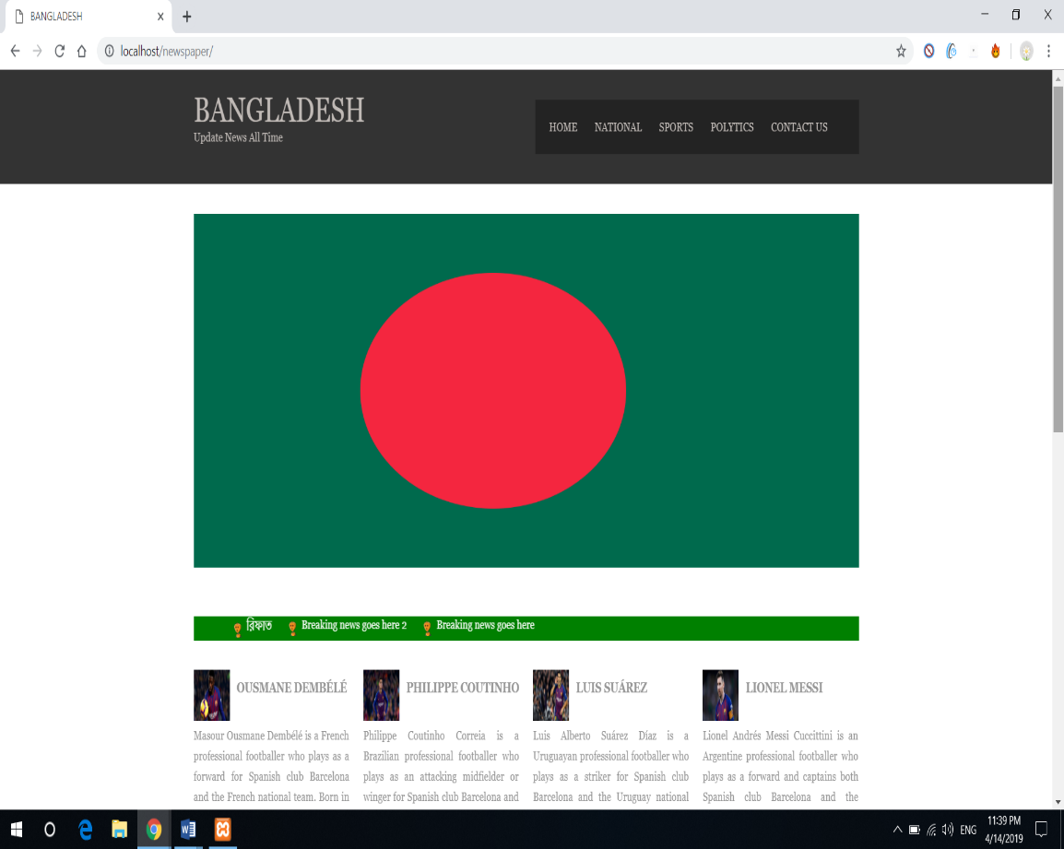

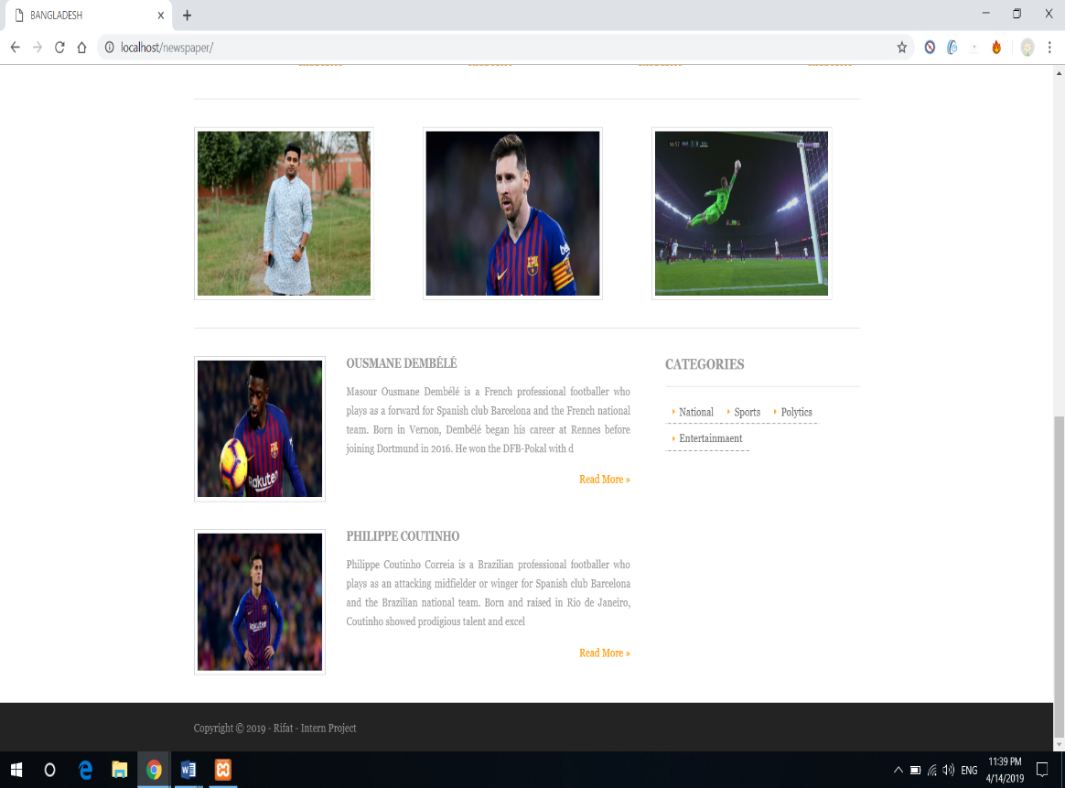

*Figure 1.1: Website Home Page of Online Newspaper*

As I am come to know from our organization venture administrator, his necessities about this web application. I made a rundown which is incorporated his need. In this manner, it is the best answer for make tweaked programming for our office, which will serve every one of the requirements in like manner.

### **1.2 Statement of Problem**

### 

They needs to make the site as unique in such a case that there any progressions required that can be refreshed at present. He gave me the obligation of this undertaking. So right off the bat I look others online paper site to accumulate learning about the UI plan and menus. At that point I chose about the highlights, in light of the fact that few out of every odd paper has same highlights or offices.

### **1.3 Objectives**

After completing the discussion with our project manager, the objectives became clear to me. Main purpose of this project is to create an Online Newspaper System for our country people to see all type of news. My job as a Web Application developer is to create a Web application of Case Management System. My goals in this project are to:

* **Create an eye catching website.**
* **Must be Responsive.**
* **Using PHP.**
* **Using Bootstrap for Design.**

### **Arrangement of the Report**

This report clarifies my three-month experience as an Intern at KiloBit Ltd. On section one, I have depicted the task foundation and clarified for what reason do I take a shot at this undertaking and what is my definitive objective with this Web application. Fundamental targets of the Online Newspaper System are likewise portrayed here. On section two, I have given a concise prologue to my host organization KiloBit Ltd. I have additionally portrayed my jobs and duties in the organization. Section three incorporates the equipment and programming that were utilized for the Web improvement venture. Programming can be created from numerous points of view, however a few methodologies are more powerful than others. I have clarified the methodologies and procedures, which we have pursued for building up the application. Part four depicts the venture that I have chipped away at while finishing my temporary job at KiloBit. I have clarified the venture with charts and imagined the execution with screen captures of Automated Office Appointment Management System. I have additionally played out some testing on the application and the outcomes are incorporated into the report. At long last, on section five, I have finished up my down to earth involvement as an Online Newspaper System created and called attention to encourage extent of improvement.

# **CHAPTER 2**

## **COMPANY PROFILE**

KiloBit, is a worldwide IT and Engineering Solutions Provider Company established in 2017. Kilobit has two branches in Bangladesh. In 2017 Kilobit began its voyage. KiloBit gives custom programming and administrations, for example, Web Application, Mobile Application, Games Development, Video Animation and Digital Marketing Services.

### **2.1 Services**

Kilobit Ltd. offers different sorts of administrations to its clients, as a main Software Development, Consulting, App development organization. Guideline benefits that Kilobit are gives given below:

* **Web Site Development**
* **Android App Development**
* **IOS App Development**
* **Digital Marketing**
* **Games Development**

### **2.2 Roles and Responsibilities**

In the wake of finishing my twelfth semester, I quickly joined KiloBit Ltd. As an Intern so as to finish my four yearlong B.Sc. degree. Despite the fact that I have taken in a great deal from my college about programming improvement, adapting up to the expert life was as yet a test for me.

At KiloBit, my primary obligation was to create web application as indicated by the prerequisites. As a group we pursued Agile Scrum strategy to create application. The whole undertaking was separated into various assignments and achievements. I was allotted with errands in each dash which I expected to accomplish so as to prop the improvement up. My obligations included distinctive errands, for example, creating application, finishing undertakings sets in runs, speaking with the venture administrator, group pioneer and some more.

# **CHAPTER 3**

## **Technologies**

So as to build up a Web local application, I have utilized a few sorts of innovations. I was included with programming improvement, so normally I needed to utilize various types of programming to manufacture, test and send the application.

### **3.1 Hardware**

I was given an amazing Desktop to deal with at my organization. Work area (OS: Windows 10, Processor: Intel Core i 7)

### **3.2 Software**

Right off the bat, I recorded some product, which I expected to do my venture work. Which was Xampp, represents Cross-Platform (X), My-SQL, PHP . It is a basic, lightweight circulation that makes it amazingly simple for engineers to make a nearby web server for testing and arrangement purposes. Simple to utilize lower RAM the executives.

### **3.2.1 Languages: PHP (OOP)**

PHP is a server-side scripting language, for the most part utilized for web improvement yet additionally utilized as a universally useful programming language. Article Oriented Programming (PHP OOP), is a sort of programming language standard added to php5, which helps in structure mind boggling, reusable web applications.

### **3.2.1 Design: Bootstrap**

Bootstrap is the most prominent CSS Framework for creating responsive and portable first sites. Bootstrap 4 is the most current adaptation of Bootstrap**.** [1]At first worked by a fashioner and designer from Twitter, Bootstrap has ended up being one of the trendiest front-end structures in the entire world. Before it wound up open-source, Bootstrap was right off the bat distinguished as Twitter Blueprint. Bootstrap is responsive, portable first, winning, and front-end structure, which is created alongside CSS, JavaScript, and HTML. Bootstrap has numerous advantages sans preparation for each web improvement task, and one such reason is the gigantic number of assets available for Bootstrap.

**1. Simple to Use:** It is incredibly a simple and quick technique in any case Bootstrap. Bootstrap is entirely versatile as well. You can use Bootstrap alongside CSS, or LESS, or additionally with Sass [after you download the Sass version].

**2. Responsiveness:** Consistently cell phones continue to become enormously mainstream, and the necessity to have a responsive site has turned out to be obligatory and significant as well. As the liquid network design changes overwhelmingly to the fitting screen goals, in this way making a portable prepared site is a smooth and simple errand alongside Bootstrap. With the utilization of instant classes of Bootstrap, you can perceive the quantity of spots in the lattice framework that you might want every segment to take part in.

**3. Bundled JavaScript Components:** Bootstrap approaches with a pack of JavaScript parts for including the usefulness that creates it in basic manner for working things, for example, tooltips, modular windows, cautions, and so forth. You can even forget the composition contents totally.

### **3.3 Work Breakdown Shape of Online Newspaper**

|  |  |  |  |  |  |  |  |  |  |  |  |
| --- | --- | --- | --- | --- | --- | --- | --- | --- | --- | --- | --- |
| Sprint |  | Week 1 | Week 2 | Week 3 | Week 4 | Week 5 | Week 6 | Week 7 | Week 8 | Week 9 | Week 10 |
| Planning |  |  |  |  |  |  |  |  |  |  |  |
| Admin panel Design |  |  |  |  |  |  |  |  |  |  |  |
| Database Design |  |  |  |  |  |  |  |  |  |  |  |
| Main Page Design (UI/UX) |  |  |  |  |  |  |  |  |  |  |  |
| Testing/Error |  |  |  |  |  |  |  |  |  |  |  |

# **Chapter 4**

## **PROPOSED PROJECT**

Amid the Internship time frame, I was doled out to chip away at make an online Newspaper. In this part, I will quickly examine about the principle modules and highlights of Online Newspaper, which I have chipped away at.

## **4.1 Project Background**

Information shearing administration is as yet one of the serious issues in Bangladesh. So as to make effectively open and share news to individuals, we chose to chip away at the undertaking named "Online Newspaper" where clients can discover any data about entire word. One of the fundamental goals of online paper is to make a simple way between general individuals.

## **4.1.1 Flow Chart for Online Newspaper**

A standout amongst the most significant employments of flowcharts are to portray through pictures how a procedure is performed from beginning to end, ordinarily in successive request. A procedure stream outline is regularly utilized in preparing to record a current procedure or to assess the productivity of that procedure. For instance, in case you're uncertain whether a particular procedure merits the time and exertion, a procedure stream chart can uncover bottlenecks or duplication of errands. You can add images to your procedure stream chart in which every image speaks to an individual or gathering in charge of an assignment, choice, or yield. Your supervisory group would then be able to decide whether any group is overextended or if a few groups are a bit much for the procedure.

### **Investigate and Fix Problems**

It's hard to fix bugs and issues in work process, in the event that you don't have the foggiest idea what turned out badly and at which arrange in the process it turned out badly. That is the reason investigating is a crucial motivation behind flowchart. To plan an investigating flowchart, you regularly start by distinguishing the issue and composing that issue in a crate at the highest point of the flowchart. You would then attract a bolt to boxes that have various potential explanations behind that issue, and afterward boxes for potential arrangements, in view of the issue you distinguished. For instance, in the event that you've distinguished the issue as disappointment with your client administration process, you would then think of various purposes behind that disappointment, which could incorporate long telephone call hold up times, disappointment with conveyance times, disappointment with the learning of your client administration reps or a discernment that your reps are inconsiderate and unhelpful. Under each of these containers, you would build up a conceivable arrangement that explicitly addresses the reason that your clients are troubled. This is only one case of how to make an investigating stream outline. Some entrepreneurs like to utilize a genuine or false model in which issues are tended to dependent on straightforward genuine or false articulations that are written in boxes on the diagram.

At first I create a login page for admin. Than admin can add a new admin for this newspaper. Of course we have a database. Than admin add news category, news, featured photo, breaking news and admin log out in last. [2]

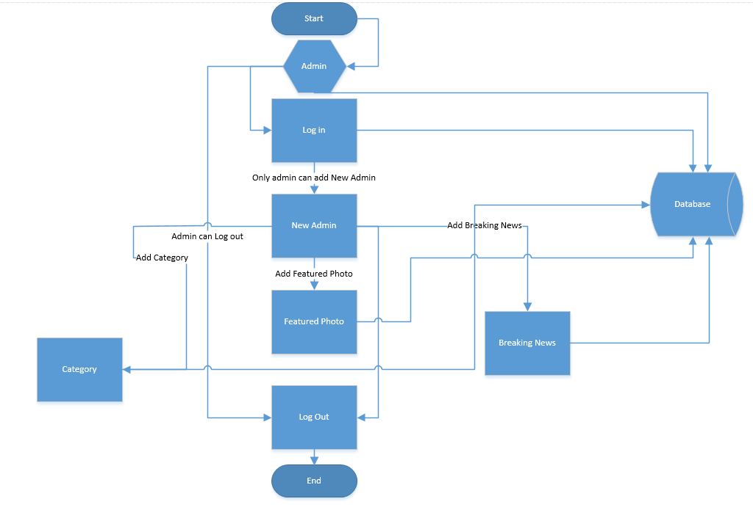

*Figure 4.4.Flow Chart*

## **4.1.2 Class Diagram for Online Newspaper**

Class graph is a static outline. It speaks to the static perspective on an application. Class outline isn't utilized for picturing, depicting, and archiving various parts of a framework yet in addition for developing executable code of the product application.

Class chart depicts the qualities and tasks of a class and furthermore the requirements forced on the framework. The class graphs are broadly utilized in the displaying of object oriented frameworks since they are the main UML outlines, which can be mapped legitimately with article arranged dialects.

Class outline demonstrates an accumulation of classes, interfaces, affiliations, joint efforts, and requirements. It is otherwise called a basic outline.

### **Motivation behind Class Diagrams**

### 

* Shows static structure of classifiers in a framework
* Outline gives fundamental documentation to other structure graphs endorsed by UML
* Accommodating for engineers and other colleagues as well
* Business Analysts can utilize class outlines to display frameworks from business viewpoint

### **Class Relationships**

A class might be associated with at least one associations with different classes. A relationship can be one of the accompanying sorts: (Refer to the figure on the privilege for the graphical portrayal of connections). [1]

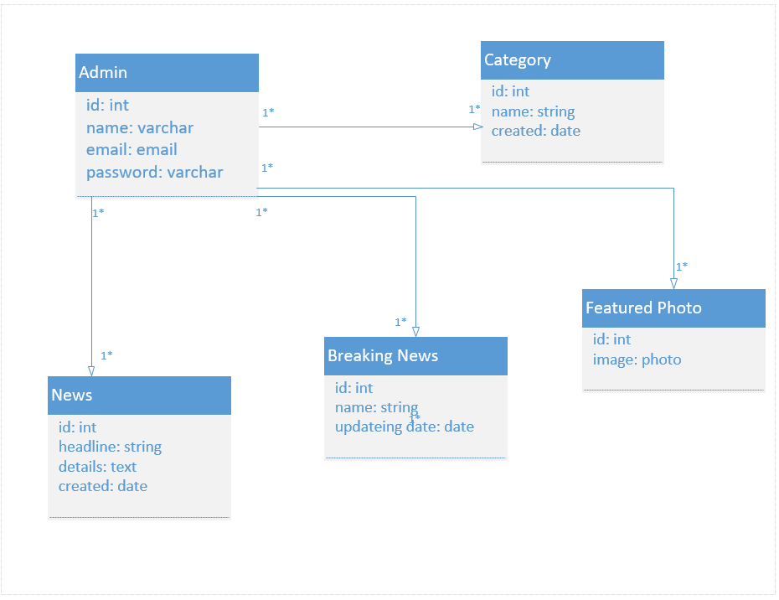

*Figure 4.5 Class Diagram*

## **4.1.3 ER Diagram for Online Newspaper**

**Database plan:** ER outlines are utilized to show and structure social databases, as far as rationale and business rules (in a sensible information model) and regarding the particular innovation to be executed (in a physical information model.) In programming building, an ER graph is regularly an underlying advance in deciding prerequisites for a data frameworks venture. It's likewise later used to show a specific database or databases. A social database has a proportionate social table and can conceivably be communicated that route as required.

**Database investigating:** ER charts are utilized to break down existing databases to discover and resolve issues in rationale or arrangement. Drawing the chart ought to uncover where it's turning out badly.

**Business data frameworks:** The charts are utilized to plan or examine social databases utilized in business forms. Any business procedure that utilizes handled information including substances, activities and interaction can conceivably profit by a social database. It can streamline forms, reveal data all the more effectively and improve results.

**Business process re-designing (BPR):** ER charts help in investigating databases utilized in business process re-building and in demonstrating another database setup.

**Training:** Databases are the present strategy for putting away social data for instructive purposes and later recovery, so ER Diagrams can be important in arranging those information structures.

**Research:** Since so much research centers on organized information, ER graphs can assume a key job in setting up helpful databases to break down the information. [2]

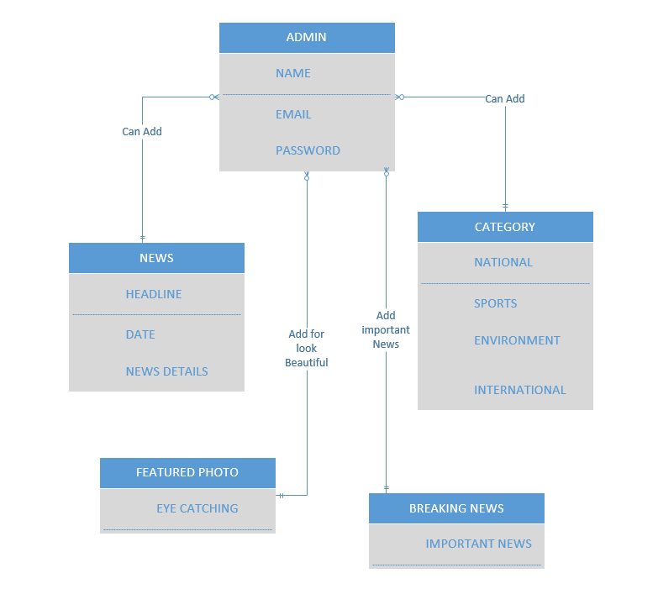

*Figure 4.5 ER Diagram*

## **4.2 Admin Panel**

Admin panel everything connected in database. Admin can add any type of news with title, describe the news and one photo. Date and Time are automating update if admin can publish the news.

The administrator board (as a rule signed into from administrator) is the place new posts, classes, labels, pages, connections and custom post types are made.

It's additionally where topic documents are changed, gadgets are included, modules are enacted or refreshed, and perusing/composing/general settings are changed.

To put it plainly, the administrator board is the place the substance is made and the site is overseen. This is the way to how a substance the executive’s framework (CMS) works. Basically, a CMS is only a progression of structures that replace physically making records and transferring them to the server. They improve that procedure.

The administrator board is simply one more arrangement of structures that let you do everything disclosed above without having to physically alter records and transfer them. [3]

### **4.2.1 Login page**

This is simple login page admin can login with valid email and matching password.

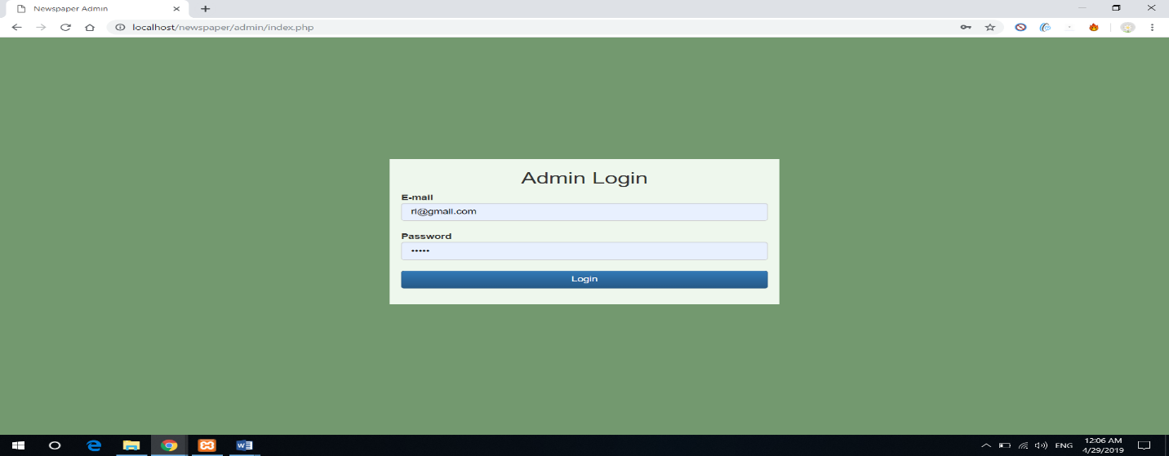

*Figure 4.2.1: login page*

### **4.2.2 Admin Home Page**

Now admin can see their home page.

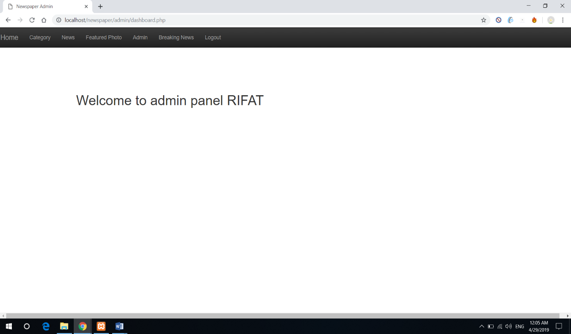

*Figure 4.2.2: Home page*

### **4.2.3 Category of News**

Admin can add many category. This category have also a menu with yes or no option. If admin select menu with yes option then this category are automatically add on the menu bar. Admin can also control every category, admin can edit and delete any category.

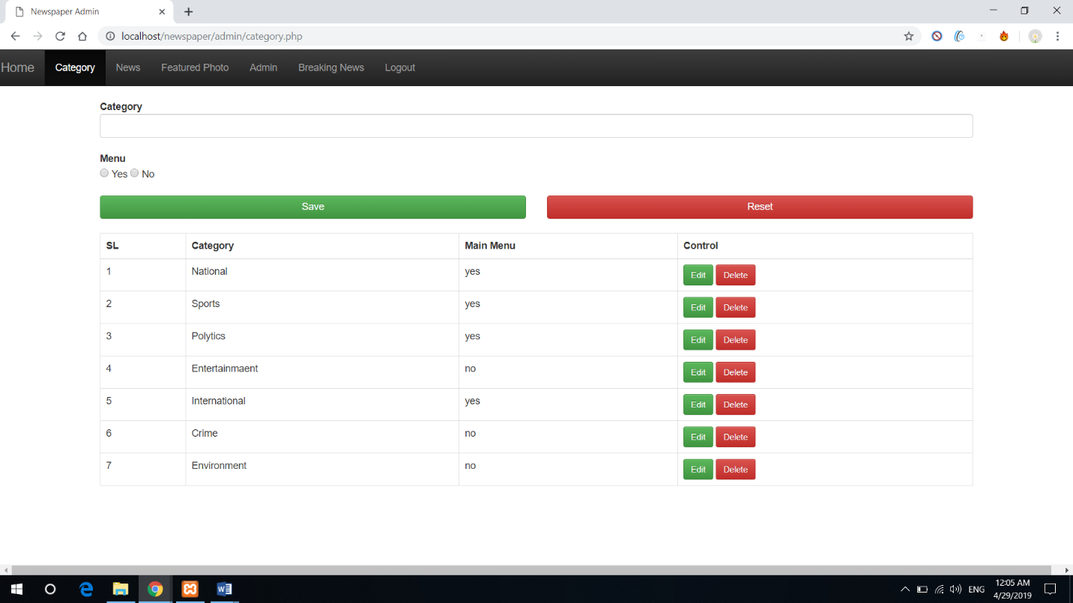

*Figure 4.2.3.1: Category*

National, Sports, Politics and International news are selected with yes option, that’s why we can see our main home page with four category in main menu bar.

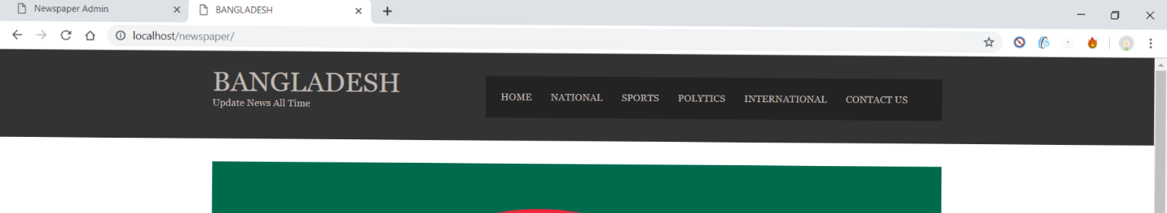

*Figure 4.2.3.2: Category with menu bar*

### **4.2.4 News**

Admin can add any news with select a category, headline, details and a photo. This page also have featured news option with yes or no option, if admin can select yes option so this news highlight in the main page. 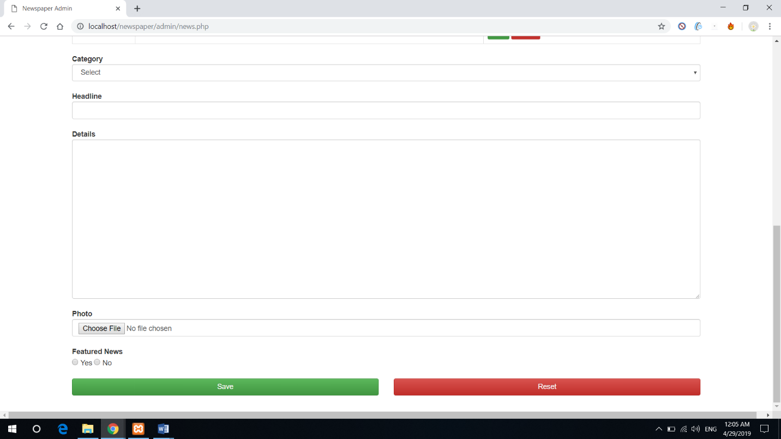

*Figure 4.2.4.1: News update*

Admin can also see the news in the admin panel table, if the news is successfully update in the main page. This table run on descending order format, so last updated news in the first with serial number, Headline and this also have a control option. There is a edit and delete option too. If admin can need any news update so admin can edit the news and if admin published the wrong news so admin can delete the news too.

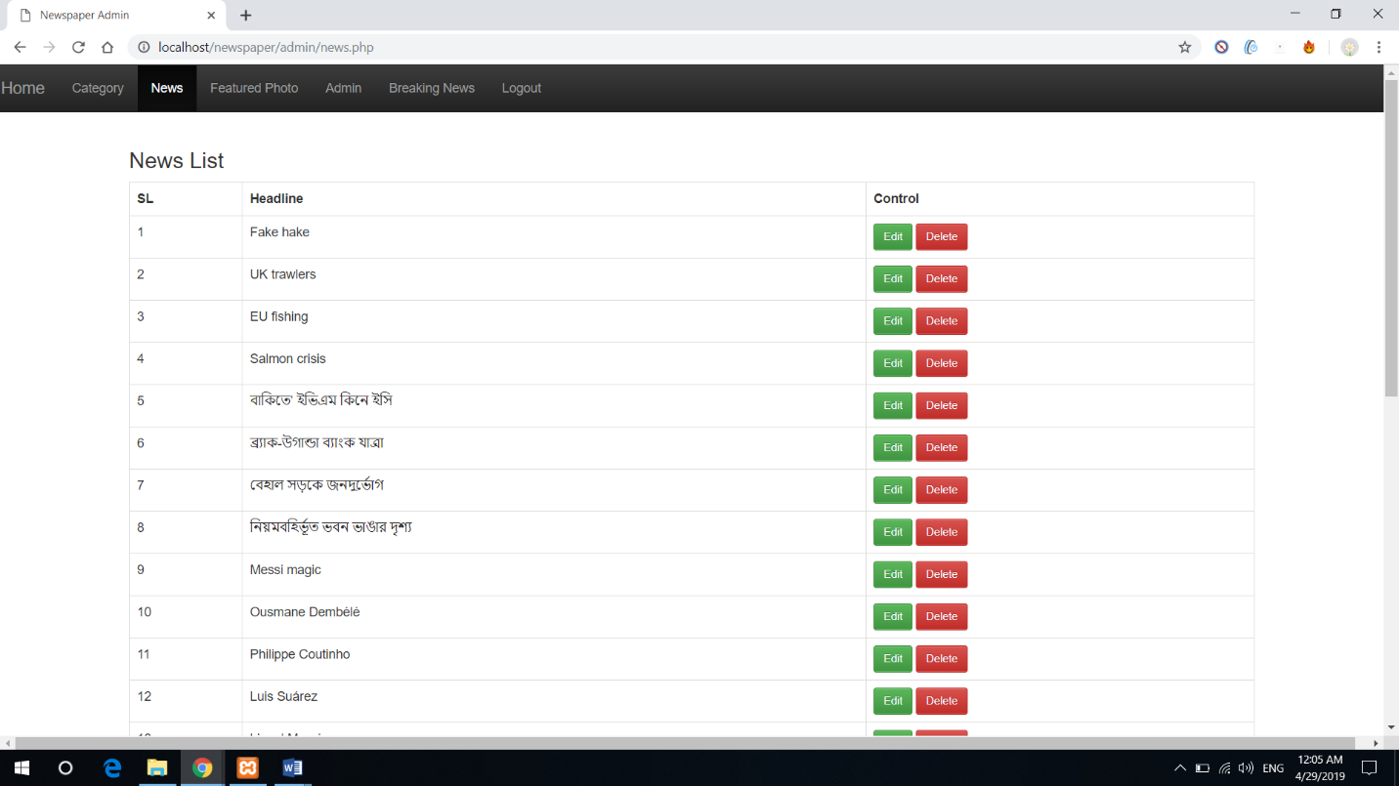

*Figure 4.2.4.2: News Table*

### **4.2.5 Featured photo**

This option only for make beautiful in this newspaper. Admin can add any photo in this section, just three photo are highlighted in this section. Last three updated photo are highlight in the every page. This three photo looks wonderful in this newspaper.

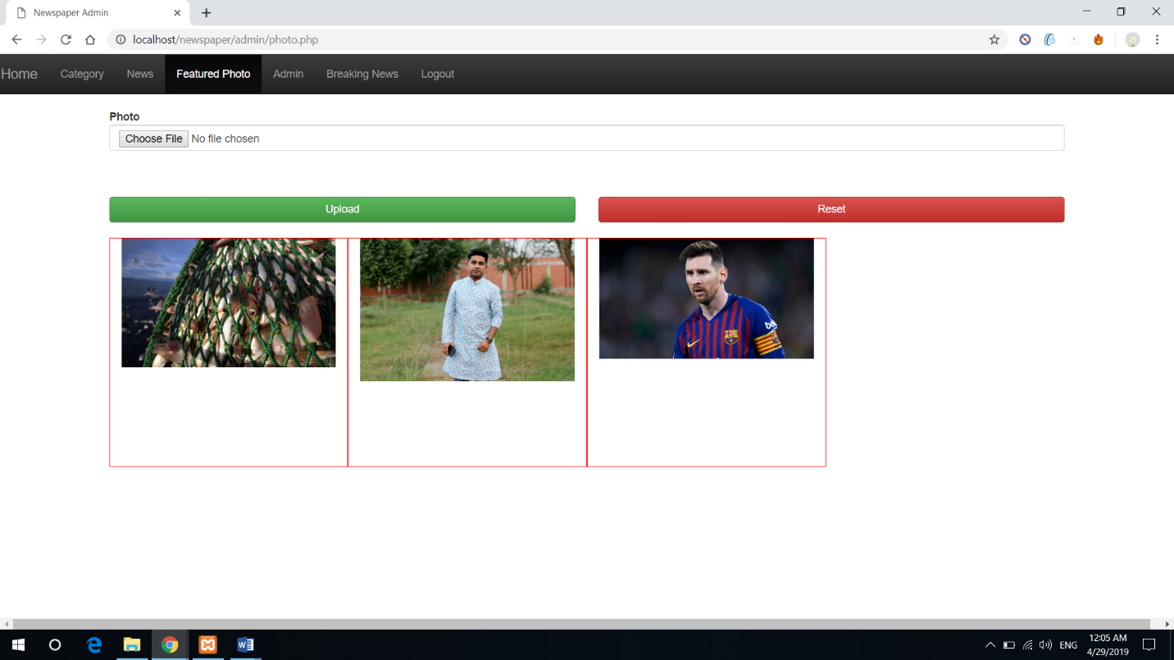

*Figure 4.2.5: Featured photo*

### **4.2.6 Admin adding**

Only admin can add new admin with name, email and password. There is an admin table also, so every admin can see all admin with name and email. Thera is a control option too, so admin can edit and delete another admin.

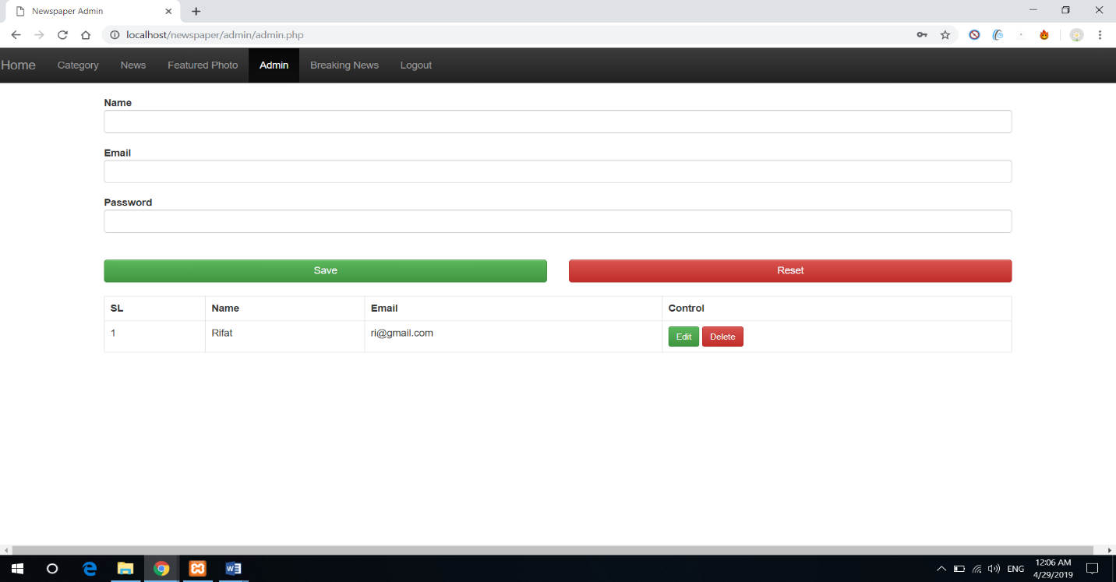

*Figure 4.2.6: Admin Table*

### **4.2.7 Breaking News**

Admin can add Breaking news. There is a Breaking news table also. Thera is a control option too, so admin can edit and delete Breaking news. Admin can add many breaking news in the newspaper and this Breaking news are highlighted in the main page in green box and this Breaking news are must be eye catching the news reader.

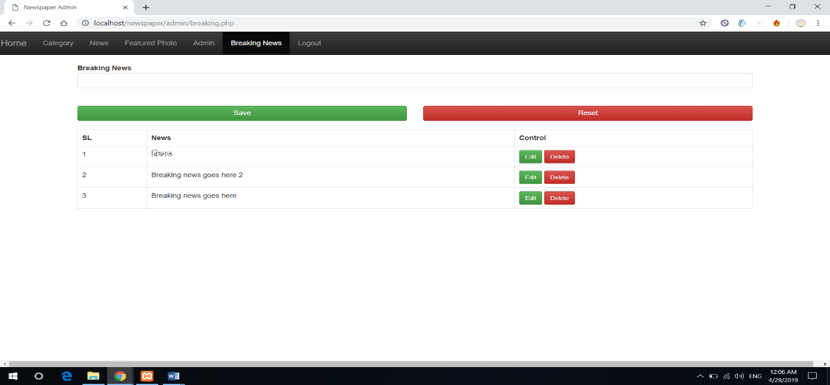

*Figure 4.2.7: Breaking News*

### **4.2.8 Logout**

Admin can logout in the admin panel. If admin click the logout button then admin see the login page.

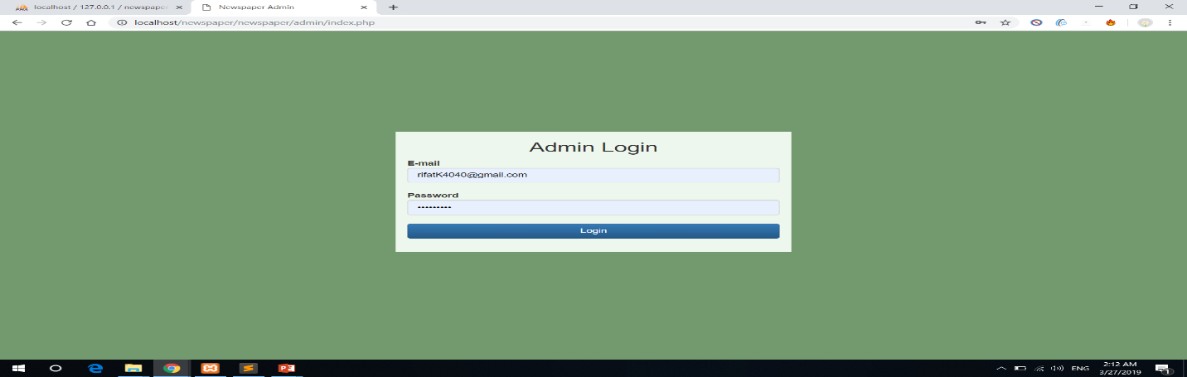

*Figure 4.2.8: Logout*

## **4.3 Newspaper page (Reader can see)**

Any reader can read any specific news. Here is some category type news also. So reader can easily read any news. One related photo also attached in news with related headline.

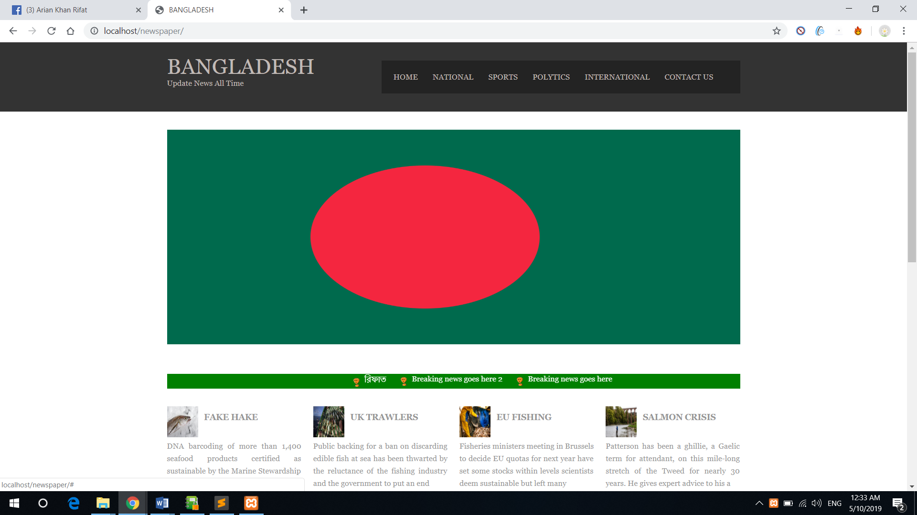

*Figure 4.3.1: Home page*

This Section reader can see Breaking News, News Category and Featured Photo. People can click any news in read more so reader can see all details in this page. People can also click in categories then reader can see category type news.

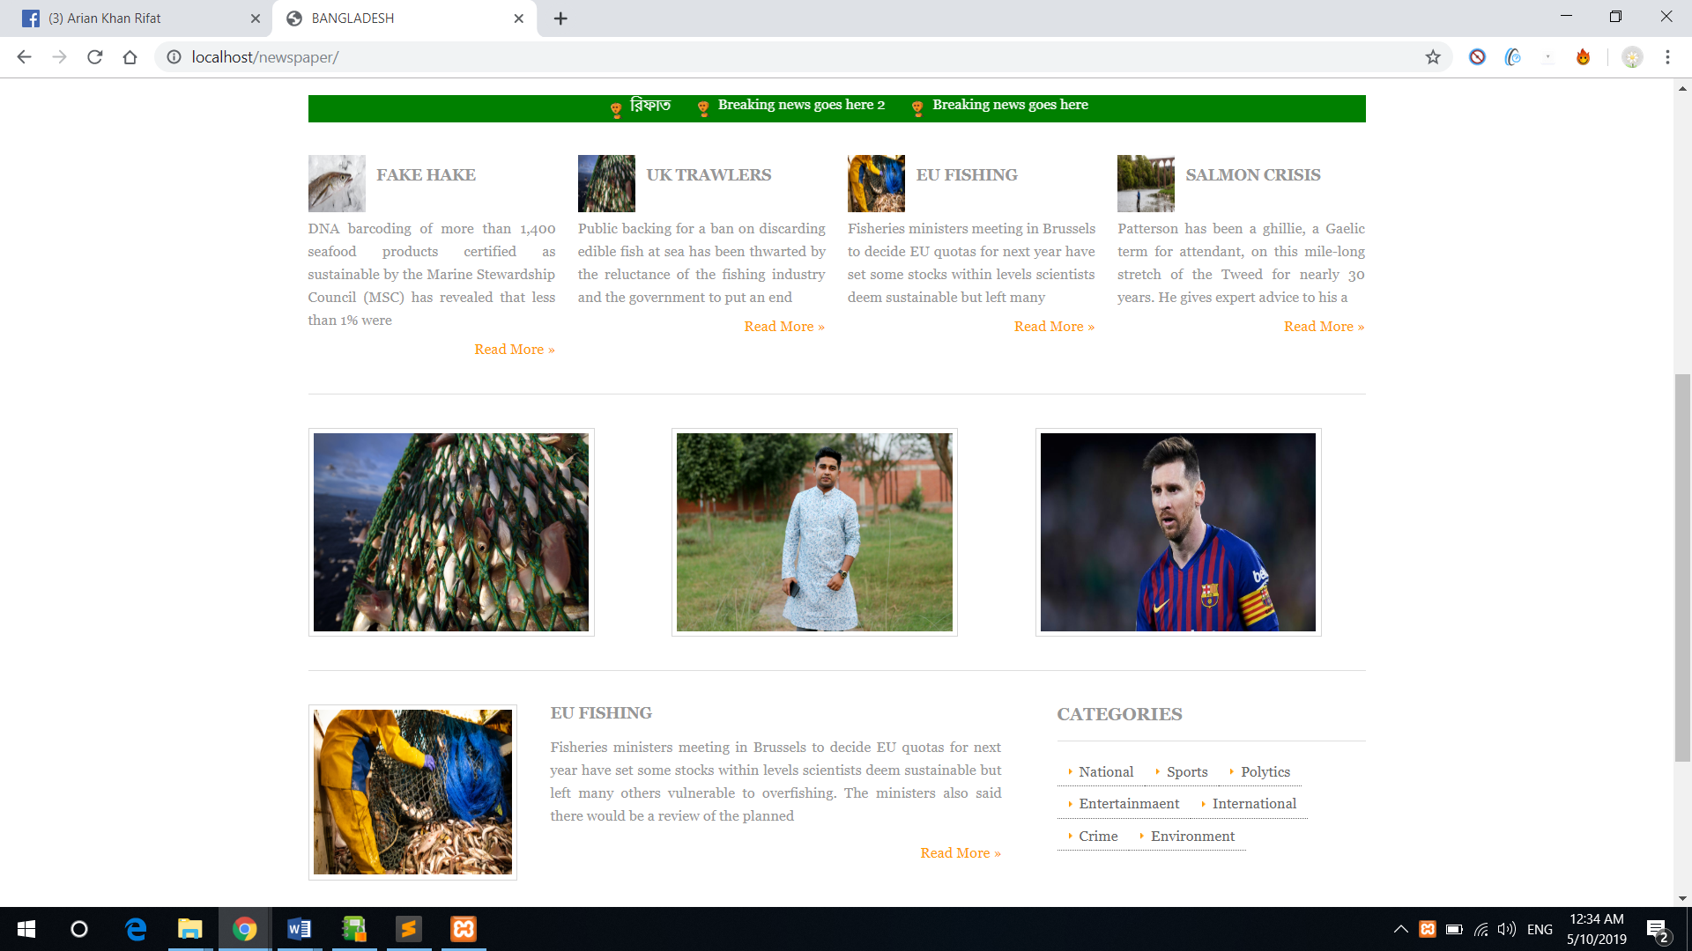

*Figure 4.3.2: Home Page*

In down part reader can see featured photo, categories and most importantly last two news. Last two update news can see every page.

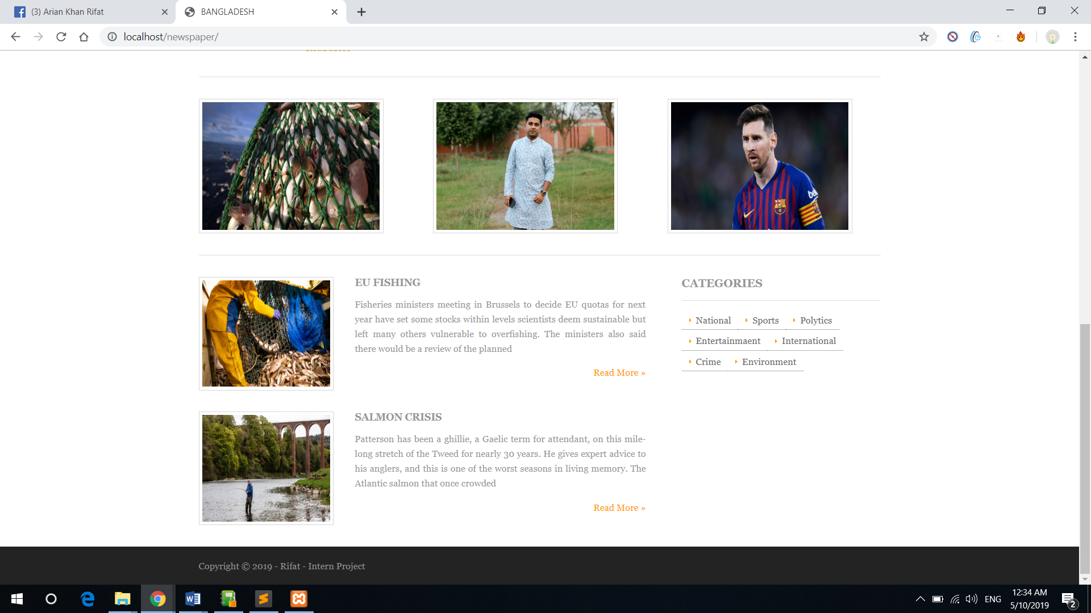

*Figure 4.3.3: Home Page*

If reader click Read more than reader can read those news with all details and open this type of page. Reader also can see date and time when this news are published.

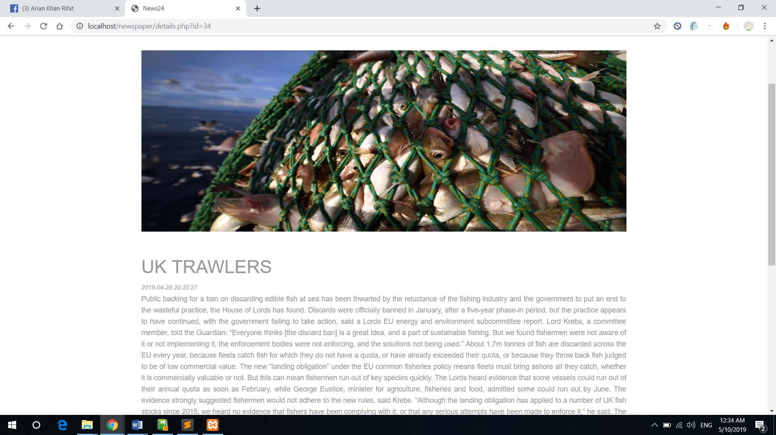

*Figure 4.3.4: News Details*

In news details page viewer can see categories with list view.

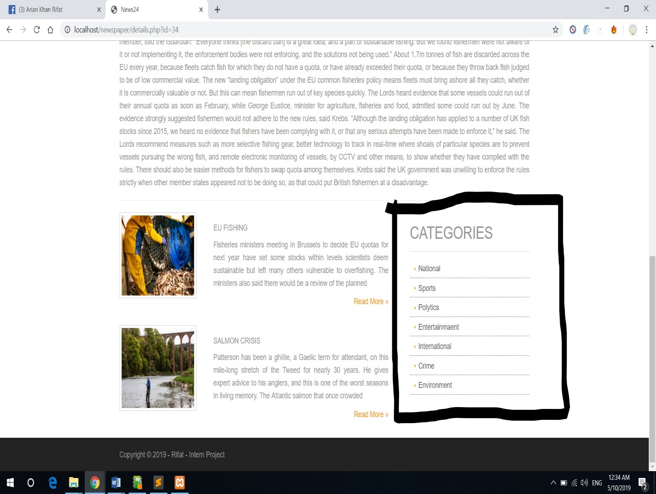

*Figure 4.3.5: News Category*

### **4.3.1 News Category**

In this page all news are sports related news. In top right side have some categories and any reader can click any categories so reader can see all related news. This time reader click sports categories and page show all sports related news.

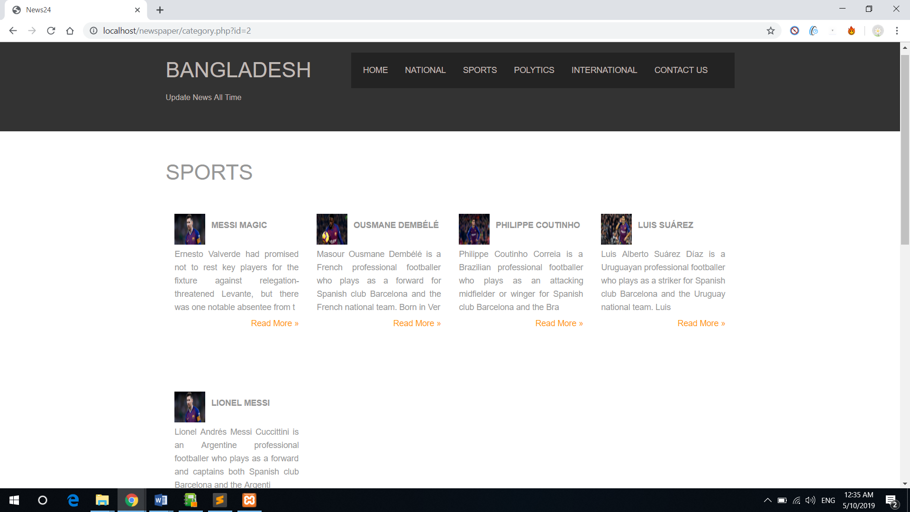

*Figure 4.3.6: News Category*

If complete sports related news than page show featured photo and last two updated news with headline and one photo. Viewer also can see all categories.

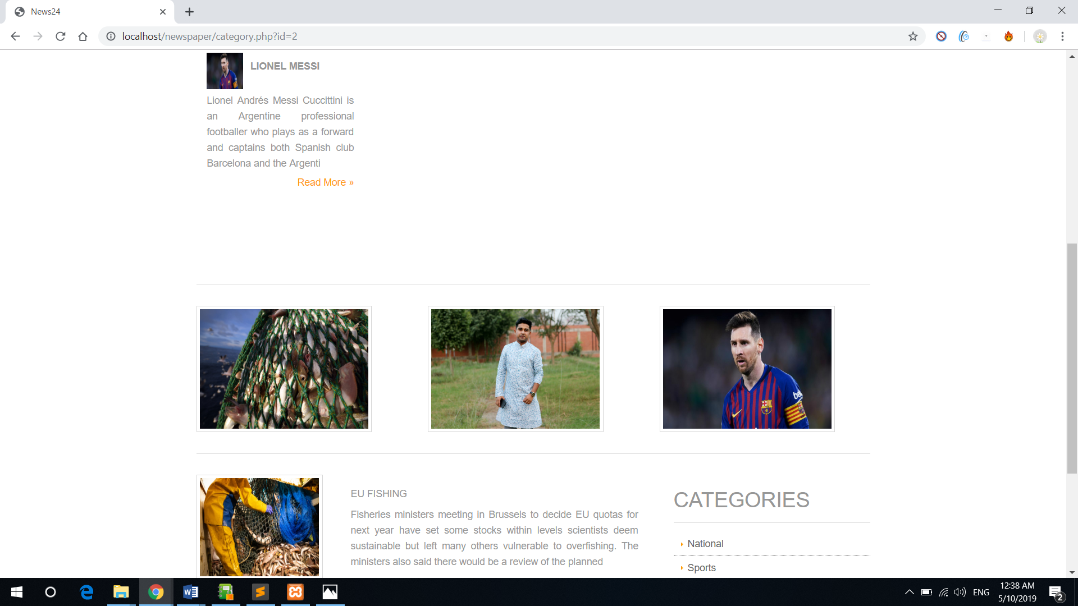

*Figure 4.3.7: News Category*

This is another category. If any reader click environment category than another page is open and this page all news are environment related.

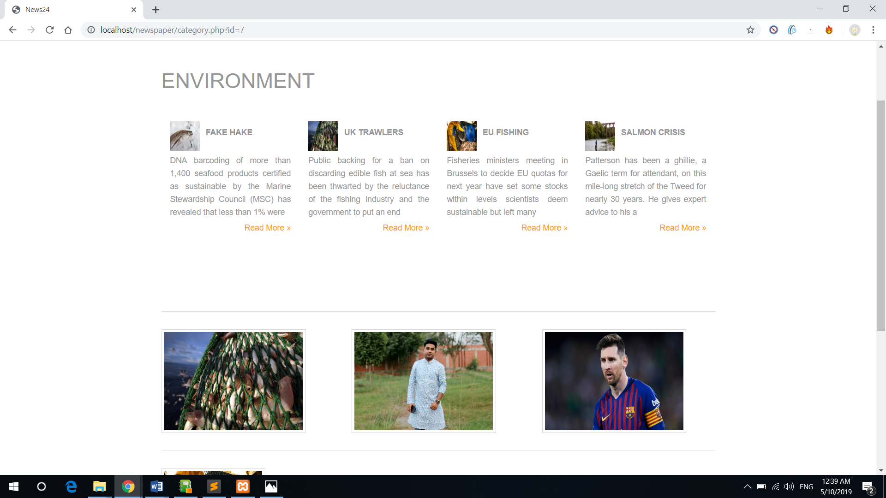

*Figure 4.3.8: News Category*

This is National Category news. If viewer click in National category so page are move in this page, and this page show all national news.

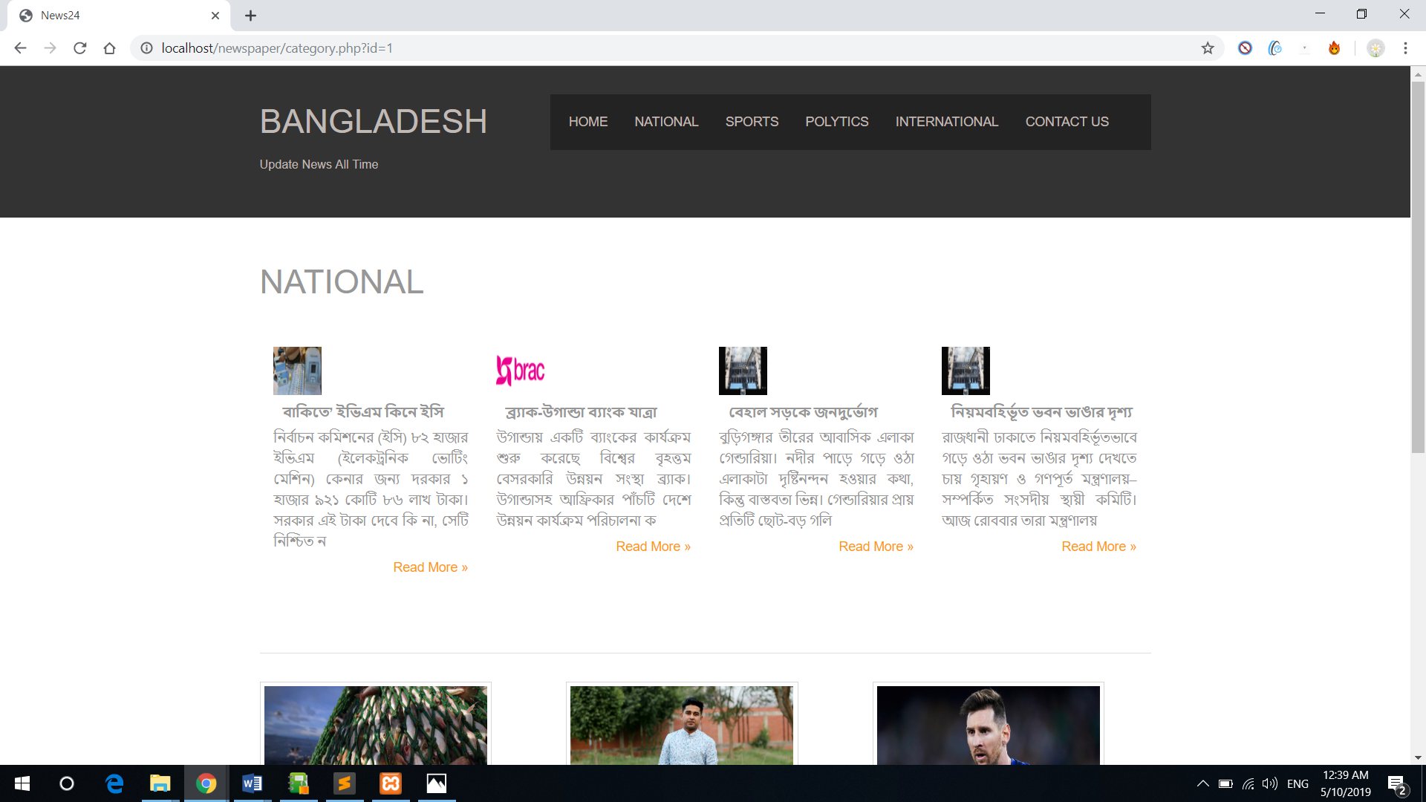

*Figure 4.3.9: News Category*

This page also perfectly support Bangla language also.

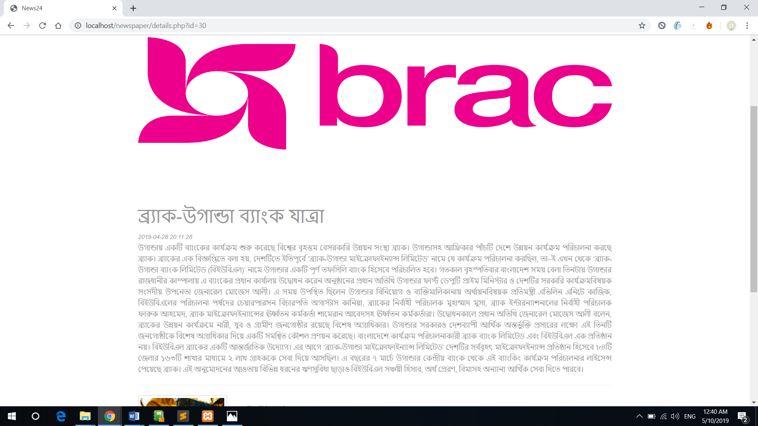

*Figure 4.3.10: News Category*

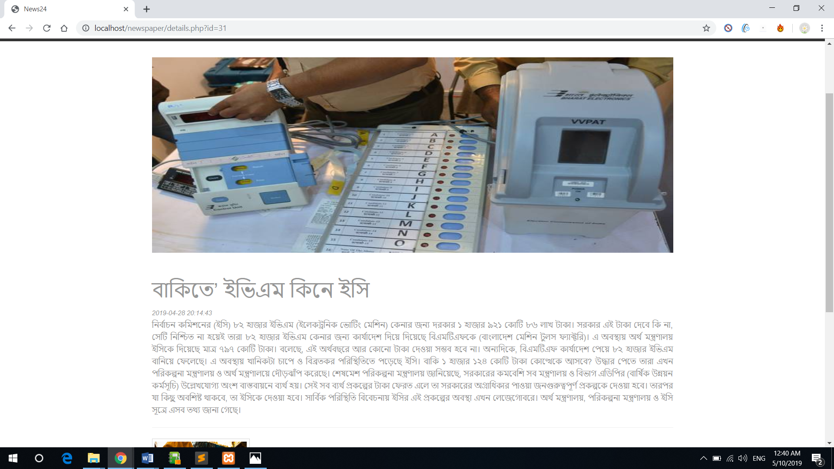

*Figure 4.3.11: News Category*

# **Chapter 5**

## **Internship Activity**

When I join in Kilobit, at first they are given me some small task and I try to complete perfectly. Here is an example and I try to prove myself in good way.

## **My Portfolio**

This is a Full Bootstrap project and this page is a fully responsive, anyone can browse in mobile, tab, Laptop etc.

### **5.1 Portfolio Home**

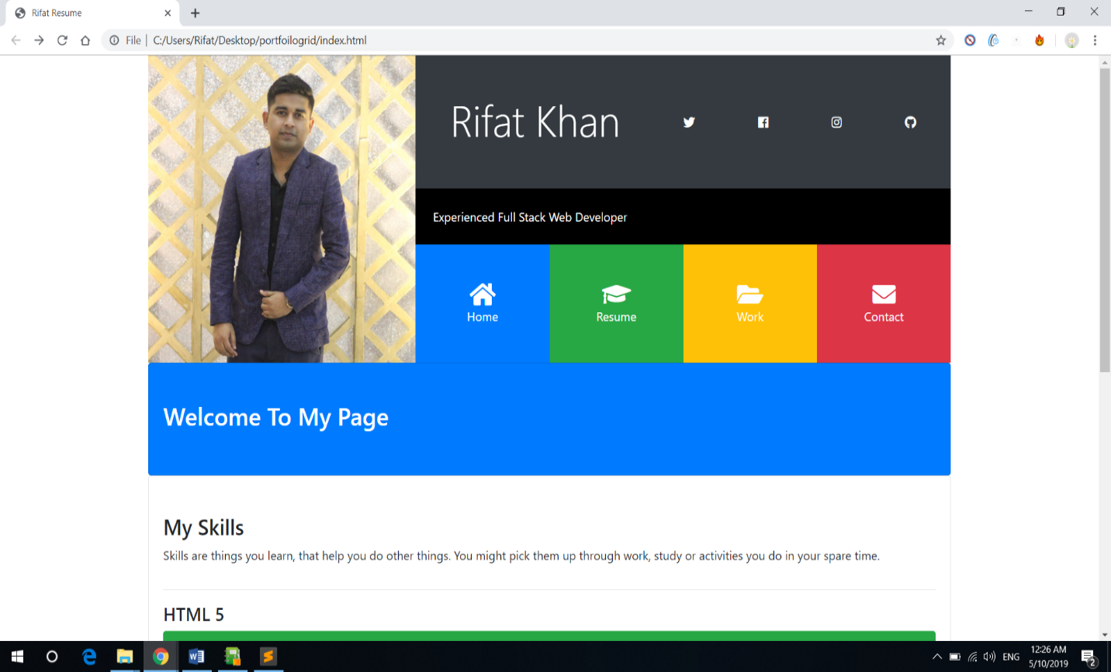

*Figure 5.1.1: Home*

This Home page have seven Skill that I have. HTML 5 and CSS 3 with 100%. JavaScript sill is 90% and other also.

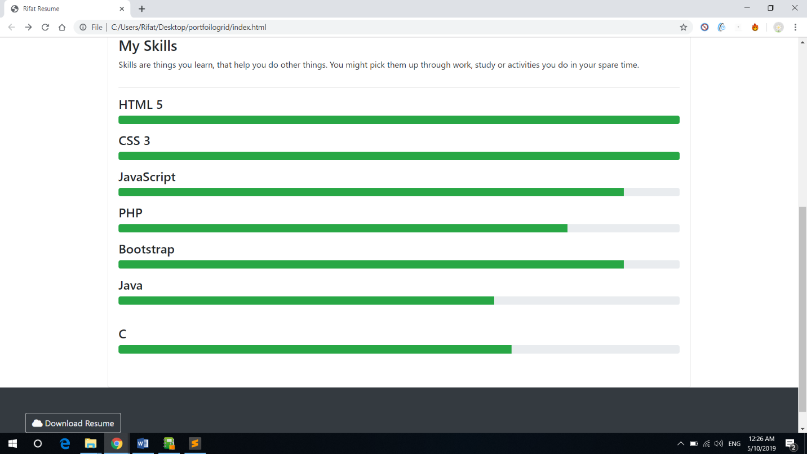

*Figure 5.1.2: Home*

This part linked with git and some social media where I active.



*Figure 5.1.3: Home*

### **5.2 Portfolio Resume**

When I have work experience than I add in this section. Now it’s some dummy example with where I worked, my position, phone number and dates also.

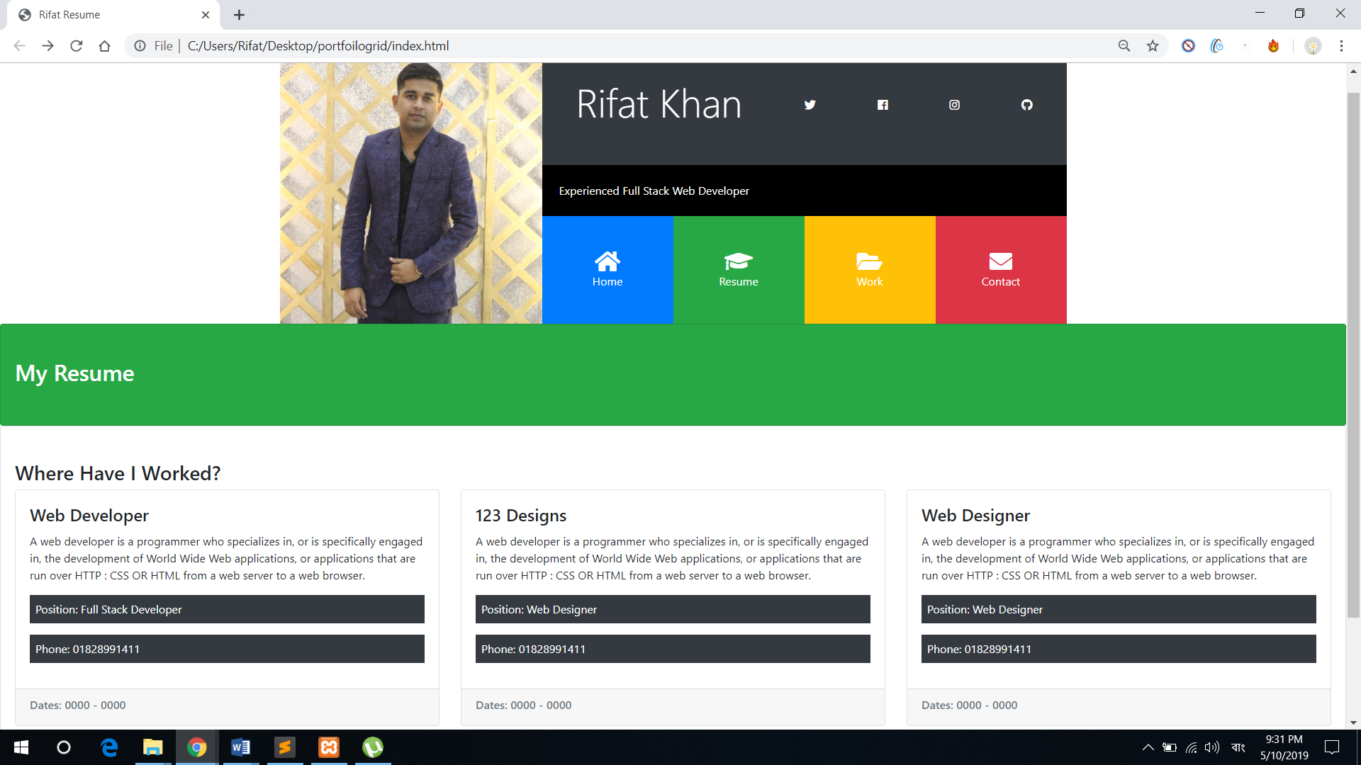

*Figure 5.2: Resume*

### **5.3 Portfolio Work**

Here I add my intern project Online Newspaper add screenshot as photo.

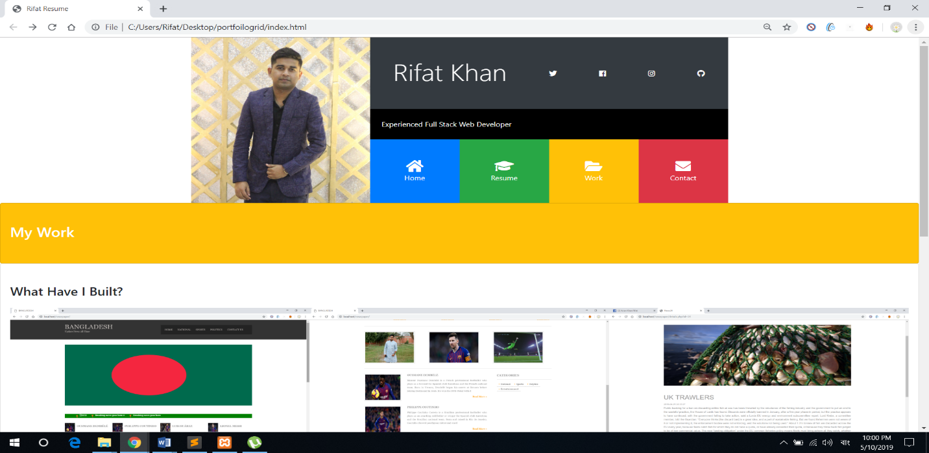

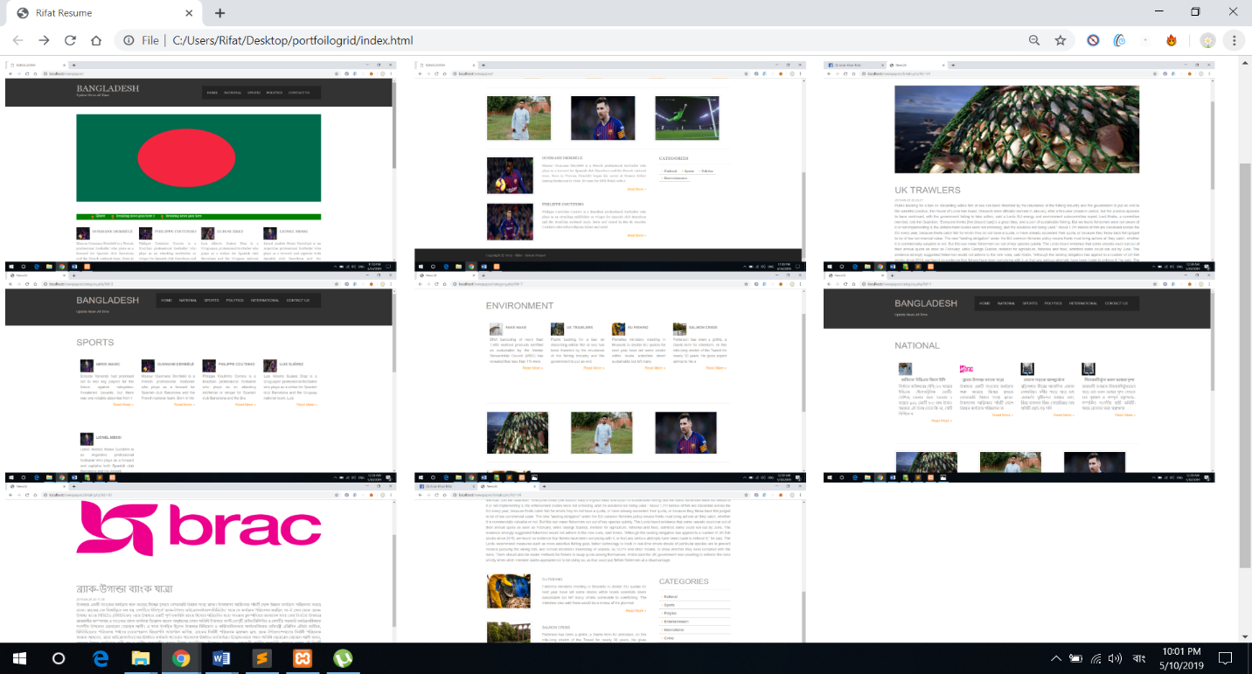

*Figure 5.3: What I built*

### **5.4 Portfolio Contact**

Anyone can contact with me through an email. Person just need a feel up from with Name, email and what message he or she send me. This is a very simple step to contact with me.

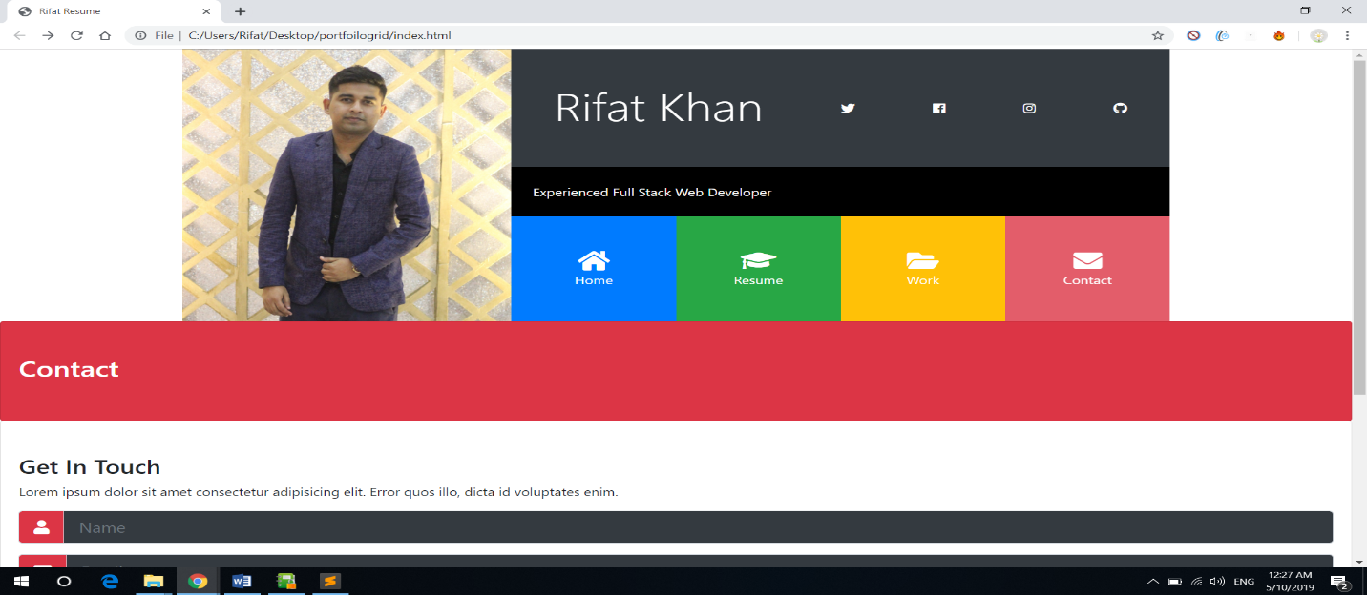

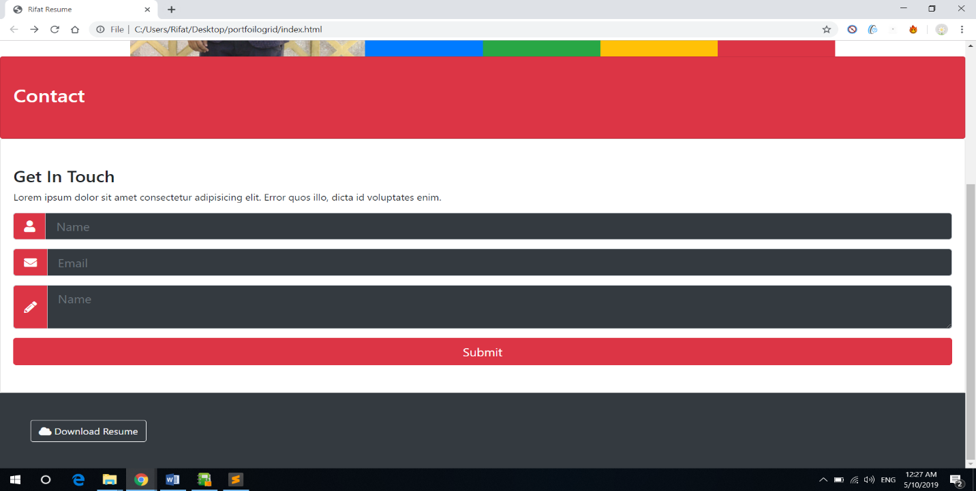

*Figure 5.4: Contact page*

# **Chapter 6**

## **Conclusion**

It has been an astonishing knowledge to function as an understudy at Kilobit Ltd. In these three months I didn't simply find out about Web improvement, yet in addition earned profitable reasonable experience of working in an association. I have never worked in an expert domain, so it was a totally new encounter for me and I discovered some new information consistently about the habits and methodologies inside an association. I am extremely glad to have the option to create a working web application in this timeframe. I have taken in the fundamental strides of creating programming in a viable methodology from my Scrum Master Mr. Murad and I am appreciated adapting each day.

While working in an expert field, it is critical to finish the undertakings relegated to you at your own obligation. I trust I have figured out how to do as such by accomplishing the objectives set by my Supervisor and my Scrum Master and creating a chipping away at the make an online Newspaper. The application can right now recover information from the database and peruse can peruse paper. I didn't simply take a shot at building up the online paper, yet additionally performed various types of exercises, for example, meeting with undertaking director for improving relational abilities, taking notes and making documentations of different activities running on Kilobit, testing on the web paper framework and above all, finding out about the methodologies of an association while chipping away at a task. An association like Kilobit dependably considers benefit and re convenience while taking a shot at an undertaking.

So as a developer, I likewise need to code in such manner that can be reused effectively for increasing more benefit.

Toward the start of my temporary job, I set a few objectives for my own improvement and I am glad to state that my objectives have been accomplished precisely that way I needed them to be. I have figured out how to adjust to an expert situation and work in a group of designers. I additionally have found out about android studio. My certainty has expanded drastically with my aptitudes as a Web designer. I am set up to work in an association and add to the development and benefit with every one of the abilities that I have gained.

## **Reference**

|  |  |
| --- | --- |
| [1] | "w3schools.com," [Online]. Available: https://www.w3schools.com/bootstrap/. |
| [2] | "Chorn," [Online]. Available: https://smallbusiness.chron.com/use-flowchart-43367.html. |
| [3] | Class Diagram [Online]. Available: https://www.visual-paradigm.com/guide/uml-unified-modeling-language/what-is-class-diagram/. |
| [4] | "Lucidchart," [Online]. Available: https://www.lucidchart.com/pages/er-diagrams. |
| [5] | "Quora," [Online]. Available: https://www.quora.com/What-is-the-admin-panel-on-a-website-and-how-does-it-releate-to-a-content-management-system. |
| [6] | "Bootstrap 3," [Online]. Available: https://www.w3schools.com/bootstrap/. |